Geometry: Unit 5, Lesson 7
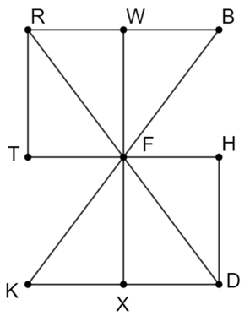
- A diagram of six triangles is shown. What is an example of two triangles that can be shown to be congruent in order to conclude that $RF≅FD$?

$$∆TFR≅∆HFD$$

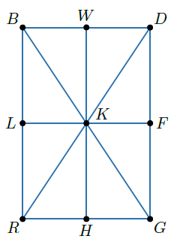

- A quadrilateral made up of eight triangles is shown. What triangles can be shown to be congruent to conclude that $\overline{WK}≅\overline{HK}$.

$$∆BKW≅∆GKH$$
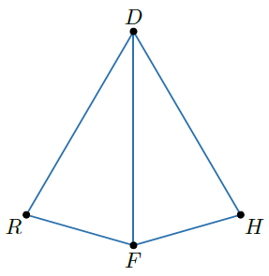
- Quadrilateral $RDHF$ is shown, where $\overline{DF}$ is the angle bisector of $∠RFH$. What is a conclusion that can be made using the given information?

$$∠RFD=∠HFD$$

